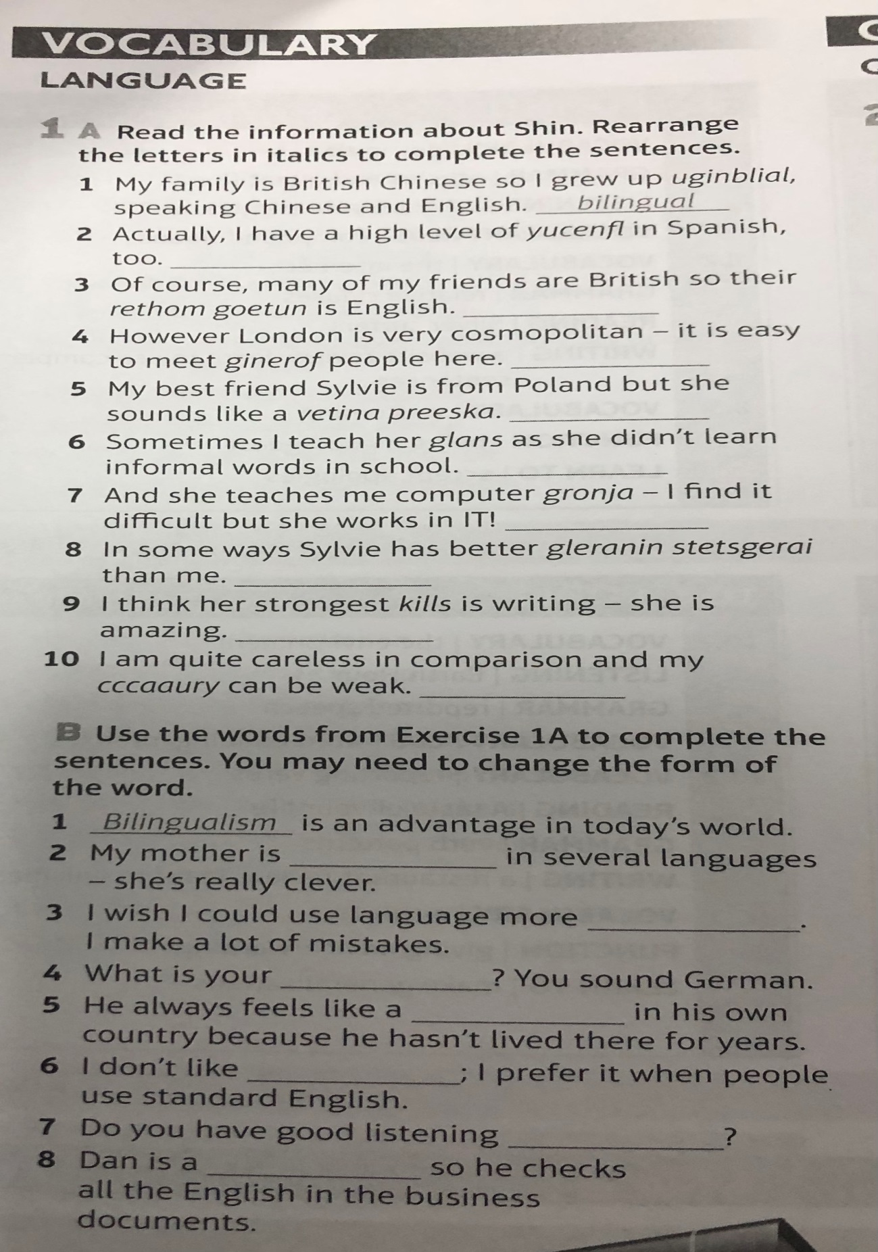

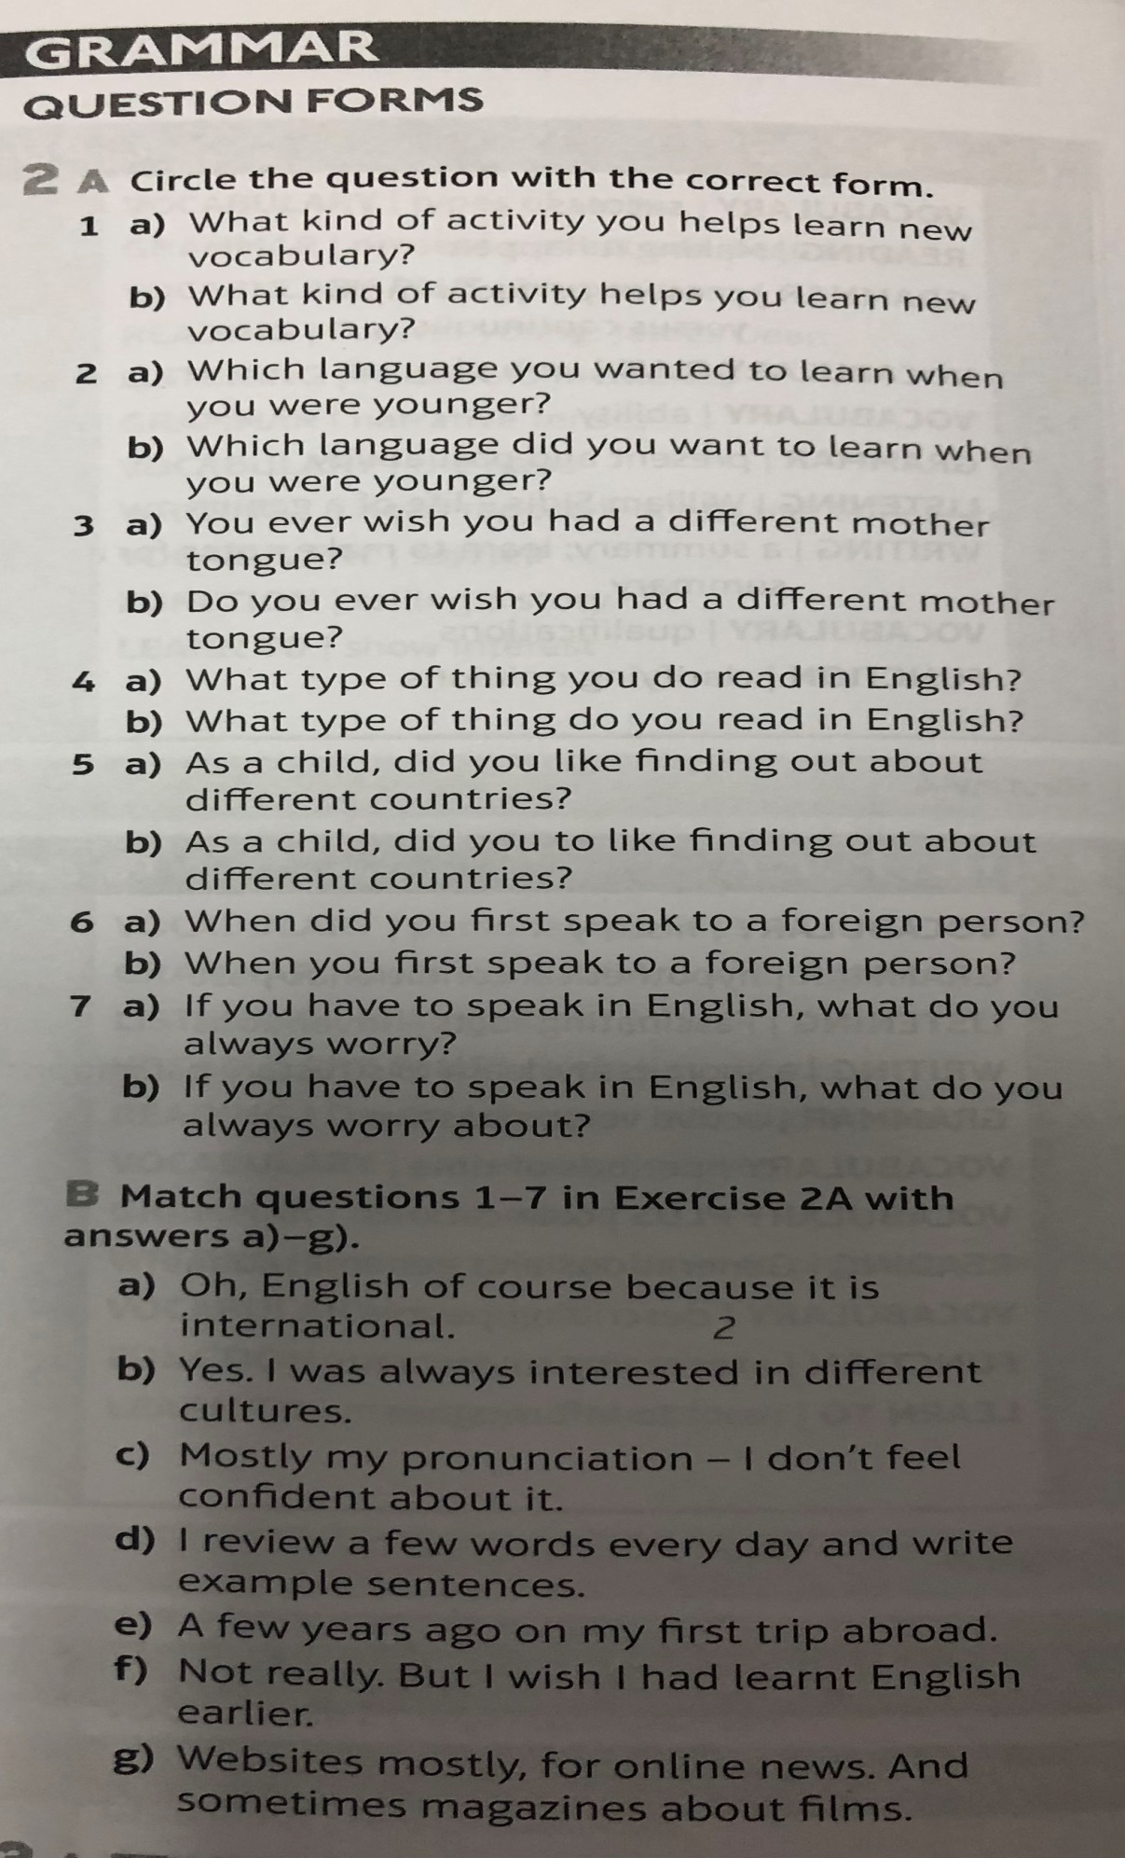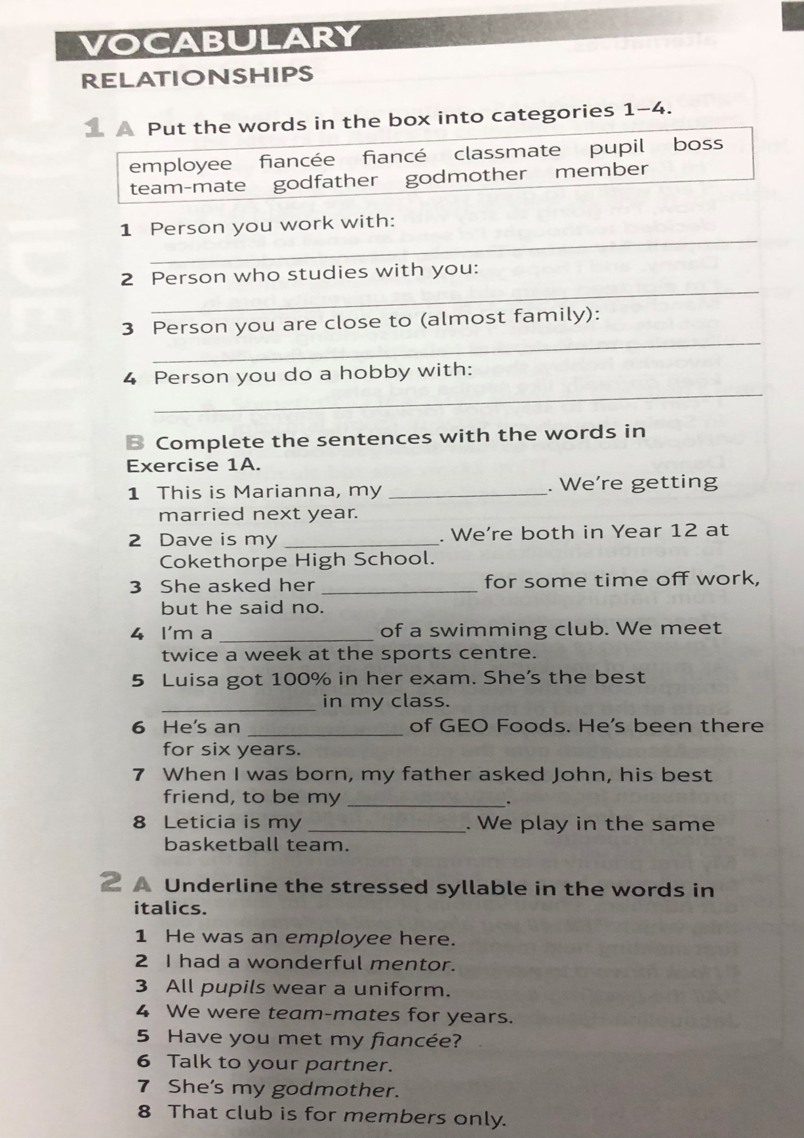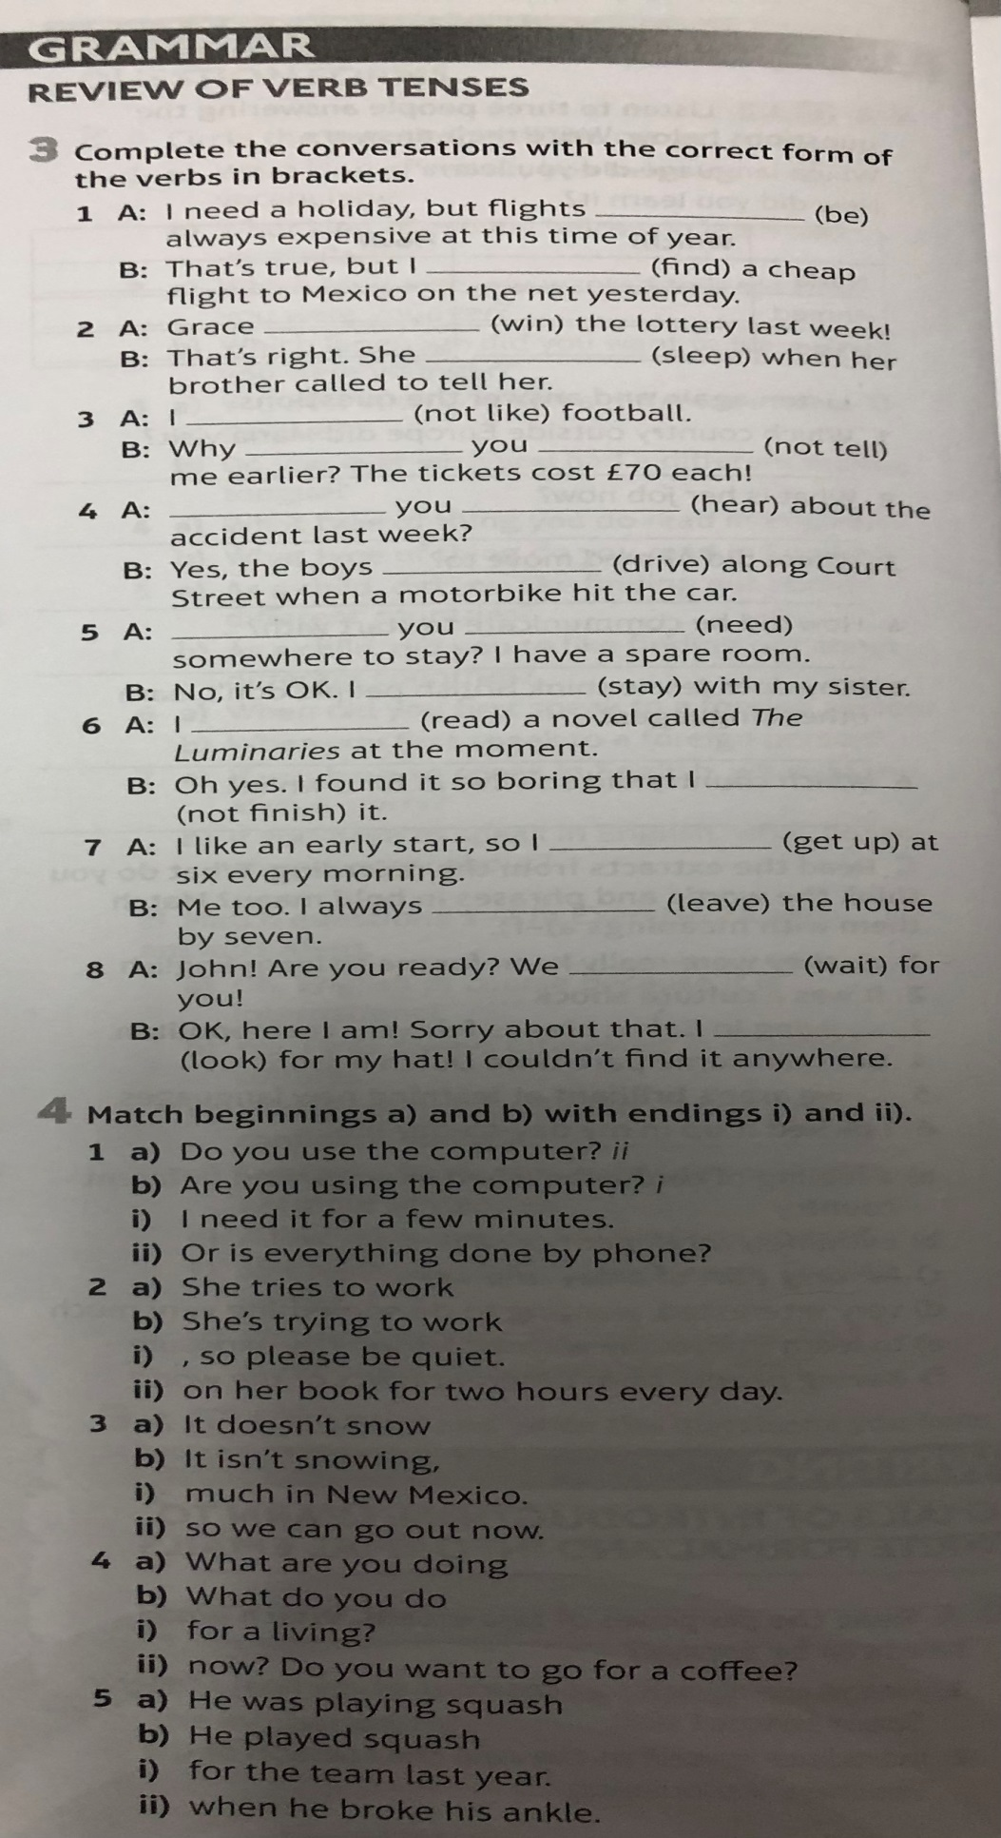

1

A)

1)**bilingual** 2)**fluency** 3)**mother tongue** 4)**foreign** 5)**native speaker** 6)**slang** 7)**jargon**

8)**learning strategies** 9)**skill** 10)**accuracy**

B)

1)**bilingualism** 2)**bilingual** 3)**accurate** 4)**mother tongue** 5)**foreign** 6)**jargon** 7)**skill**

8)**native** **speaker**

-------------------------------------------------------------------------------------------------------------------------------------------

2

A)

1)**b** 2)**b** 3)**b** 4)**b** 5)**a** 6)**a** 7)**b**

B)

a)**2** b)**3** c)**7** d)**1** e)**6** f)**5** g)**4**

-------------------------------------------------------------------------------------------------------------------------------------------

1

A)

1)**employee**, **boss**, **team-mate** 2)**classmate**, **pupil**, 3)**fiancee**, **fiance**, **godfather**, **godmother** 4)**member**

B)

1)**fiancee** 2)**classmate** 3)**boss** 4)**member** 5)**pupil** 6)**employee** 7)**godfather** 8)**team-mate**

-------------------------------------------------------------------------------------------------------------------------------------------

3

1) A: **are** B: **found** 2) A: **won** B: **was sleeping** 3) A: **don’t like** B: **didn’t / tell** 4) A: **Did / hear**

B: **were driving** 5) A: **Do / need** B: **‘m staying** 6) A: **am reading** B: **didn’t finish** 7) A: **get up** B: **leave**

8) A: **are waiting** B: **was looking**

4 1 a) **ii** b) **i** 2 a) **ii** b) **i** 3 a) **i** b) **ii** 4 a) **ii** b) **i** 5a) **ii** b) **i**